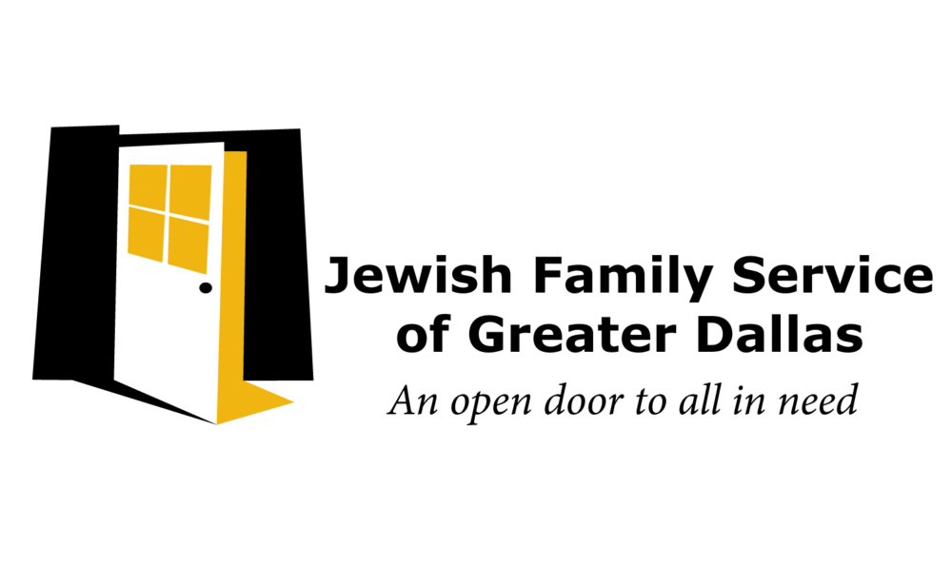
Contact Information MEDIA ADVISORY
Jewish Family Service of Greater Dallas Jamie Denison, Director of Marketing (972) 663-5533
jdenison@jfsdallas.org

Release Date: November 15, 2021

One Year Later: Another 1,000 Turkeys to be Given Out at Thanksgiving Drive-Thru Food Distribution
When: Monday, November 22, 2021 from 9:00am-12:00pm - Members of the media should arrive by 8:30am
Where: Jewish Family Service - 5402 Arapaho Road, Dallas, TX
What: One year after Jewish Family Service of Greater Dallas distributed 1,000 turkeys to families in need at the height of the pandemic, 45 Food Pantry volunteers will be operating a drive-thru food distribution to distribute Thanksgiving fixings to families still facing food insecurity in Dallas. Individuals and families will receive a turkey, vegetables, cranberry sauce, muffin and stuffing mixes, gravy and more while staying safely in their car. This is the last distribution before clients head inside to the newly expanded JFS Food Pantry, set to open to the public one week later, December 2. Media is welcome inside to see the new space as well.

“For many people, this Thanksgiving may feel relatively normal compared to last year, but the lines of cars we’ve seen every Thursday - even one year later - serve as a reminder that so many are still facing hardships,” said JFS’ CEO Cathy Barker. “We are thankful for all the volunteers and donors who are helping us serve those in need once again.”

JFS has operated 75 drive-thru food distributions since May 2020, which have taken place almost every Thursday. The agency is a long-standing partner of the North Texas Food Bank.

The nationwide supply chain issues have made the cost of turkeys and other holiday fixings skyrocket. For families that are struggling to get by, community pantries like the JFS Food Pantry are able to ensure that all have food on the table this Thanksgiving.
Jewish Family Service of Greater Dallas (JFS) is a nonsectarian mental health and social services agency
that impacted over 32,000 lives in the last year. For more than 70 years, the JFS mission has been to provide effective, accessible, and comprehensive mental health and social services that promote lifelong self- sufficiency and well-being for the Greater Dallas community. JFS welcomes anyone through it’s doors regardless of race, ethnicity, religion, or the ability to pay and has more than 150 programs and services available to all in need.

